
 |  |  | 
 |  |  | 

Web Site Architecture

“Framework contract for the provision of forest data and services in support to the European Forest Data Centre”
Reference: 2007/ S 194-235358 of 09/10/2007

Contents

1 Introduction 3
1.1 Coding Conventions 3
1.1.1 PHP 3
1.1.2 Javascript 3
1.2 Coding Rules 3
1.2.1 PHP 3
1.2.2 Javascript 4
1.3 Web site Architecture 4
2 Controllers 5
3 Session variables 6
4 Authentication 7
5 File upload mechanism 8
6 Data Submission Lifecycle 9
7 Interface 10
7.1 Query Panel 10
7.1.1 Field Type 11
7.1.2 Request generation 11
7.2 Map Panel 13
7.3 Result Panel 14
7.4 Detail view 14
7.5 Predefined Requests 15
8 Layer Management 17
8.1 Layer restrictions 18
8.1.1 Restriction by country 18
8.1.2 Restriction by profile 18
8.1.3 Restriction by activation 18
8.2 Layer styling 19
8.2.1 Architecture 1 19
8.2.2 Architecture 2 19
9 Annexes 20
9.1 Deployment 20
9.1.1 Javascript build 20
9.1.2 User extension for extjs 20
9.1.3 Patch and locale 20
9.1.4 Openlayer extensions 21

Introduction

Coding Conventions

PHP

The web site is built using the Zend Framework v1.7.8.

As a general rule, the PHP conventions and the conventions defined by the Zend Framework should be applied (http://framework.zend.com/manual/en/coding-standard.html).

- For the indentation, we rely on Eclipse default values (tabulations instead of spaces) and automatic formatting (CTRL + SHIFT + F).
- Classes, methods and attributes names are “camelCased”.
- Constants are capitalized.

Javascript

As a general rule, the PHP conventions and the conventions defined by the Extjs Framework should be applied.

- For the indentation, we rely on Eclipse default values (tabulations instead of spaces) and automatic formatting (CTRL + SHIFT + F).
- Methods, constants and attributes names are “camelCased”.
- Classes are “CamelCased” and start by an uppercase letter

Coding Rules

In addition to the coding convention, we define a set of rules that should be applied.

PHP

- We should never pass parameters to a function by reference.

Controllers

- Actions leading to the simple display of a page are named “showXXX”.
- Actions validating a form are named “validateXXX”.

Models

- Each SQL request must be logged.
- The SQL requests must be written in plain SQL (no SQL code generation by the framework).
- The SQL requests must be executed as prepared statements (no dynamic SQL).
- Model methods should return objects the are defined by a class and avoid returning associative arrays.

- The web site only does SELECT query on the raw_data schema, all the INSERTS and UPDATES are done by the integration service.

Views

The views are stored in the “views” directory of the application and are sorted in sub-folders using the name of the controller calling the view.

Classes

All PHP objects used by the application should be properly defined in a class, stored in the “classes” directory. We should avoid using Arrays or unnamed objets..

Javascript

- The application files structure must be identical to the extjs structure.
- The user extension files for extjs must be placed into a separated directory named ‘extjsux’.
- The application files must be placed into the ‘genapp’ directory.
- The code settings and the comments must be identical to the extjs code settings and comments.
- All new application class must be placed into the ‘genapp’ namespace.

Web site Architecture

The web site is built using a Model-View-Controller (“MVC”) architecture in order to have a clean code and facilitate its maintenance, we use the Zend framework.

Controller
Model
View
DB
Relational Mapping
Routing: Index.php + controller files
Presentation: View Files

Classes

Controllers

We have created the following controllers

AbstractOGAM
Query
Integration
Harmonization
Proxy
User
Map
User Managenent
Data Edition

All the controllers (apart from the UserController) extends from the AbstractOGAMController which is used to check the rights of the logger used to access the functionality.

Session variables

We store in session the following information:

Auth namespace

The “auth” namespace is used to store the “salt” variable used to implement the Challenge-Response based authentication mechanism.

- salt : a randomly generated string used to create a challenge

WebSite namespace

The “website” namespace is used to store some information about the current navigation context of the user.

- module: the name of the module currently used by the user
- moduleLabel: the label of the module (to show on the breadcrumb bar)
- moduleURL: the link to the main page of the module
- SQLQuery: the sql request currently run by the user
- SQLWhere: the FROM / WHERE part of the SQL request currently run by the user
- count : The number of lines of result
- sort : The columns used to create a unique sort order (to ensure consistency between requests)
- metadata: the metadata corresponding to the request currently run
- traductions: the traduction of the codes used by the current request
- leafTable : the logical name of the lowest table in the hierarchy of the request. This is used in the detail view to know how to rebuild the detail SQL request.
- datasetID : the name of the currently used dataset (JRC Request).

User namespace

The “user” namespace contains the information about the currently logged user.

- user : a “User” object defining the name, the login and the country of the user
- role : a “Role” object defining the role of the user
- permissions : an array of [String / String] defining the permissions of the user.

Submission namespace

The “submission” namespace contains the information about the current status of the data submission.

- location : a “Submission” object indication the identifier of the plot location submission.
- data : a “Submission” object indication the identifier of the plot location submission.

Mapping namespace

The “mapping” namespace contains the information about the available layers.

- activatedLayer : The logical name of the currently activated layer.

Authentication

The web site is protected by a challenge-response authentication mechanism (a key is composed on the client side using SHA-1 in javascript and it must match the same key generated on the server side in PHP).

The users have to be connected to access the web site. Each user have a profile and each profile is linked to a list of permissions. The rights are stored in the “website” schema of the eforest database.

In order to keep the authentication management simple, each PHP controller is linked to a domain of the web site and to a single permission. For example, if a user is given the “PRIVATE_DOCUMENTATION” permission, he will be able to access the private documentation controller and all the web site pages managed by this controller.

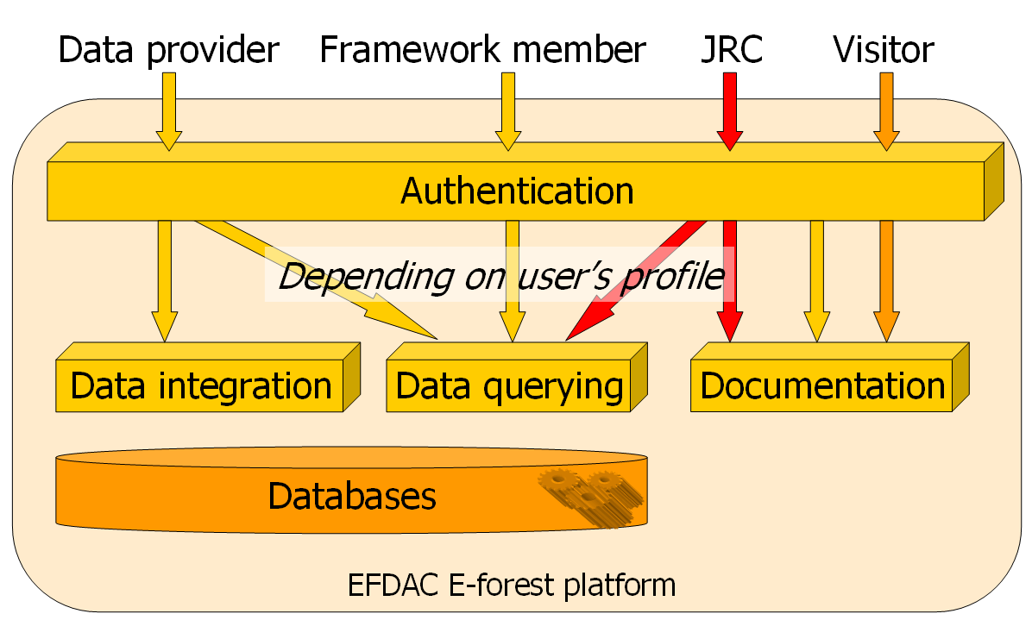

File upload mechanism

When submitting data, we need to upload some files to the server.

The file upload process contains different steps. Even if we are on one physical server, we have two different logical applications : the PHP web site and the integration service. Each application will have a local directory for storing the uploaded files. Furthermore, when doing an upload in PHP, the file is first created in a temporary directory and then need to be moved.

Each file will be stored in a directory named after the following naming convention :
/basedir/submission_id/submission_type/filename

Browser

Web Site
PHP

Integration Service
JAVA
Temp Upload Dir
Upload Storage Dir
Temp Upload Dir
Upload Storage Dir
File
Rename

- The base directories are specified in the config.php file for the web site and in the database for the integration service.
- The reference file is the file stored in the web site, it is sent to the integration service only to be read locally and stored as a backup.
- When the user is asking for a file via the browser, it is the file stored on the PHP web site that is sent.

Data Submission Lifecycle
See the “Integration Service – Architecture” document for more information.

The data submission process is decomposed in different steps. The data must be checked for compliance (data can be inserted in database) and conformity (data passed the rules check) before to be validated.

For a given JRC Request and a given country, the data is linked to the notion of a submission.

A submission can be in different steps (the current process) and have different status (the result of the processing).

List of status:
- OK
- WARNING
- ERROR (functional error with the data)
- CRASH (for technical problems)

List of steps:
- INIT (default step, nothing done)
- DATA_INSERTED (files have been uploaded and data is inserted into database)
- DATA_CHECKED (conformity checks have been processed)
- DATA_VALIDATED (data have been validated)
- CANCELLED (submission have been cancelled by a new one for the same country/year)

Location Submission Steps Diagram :

0
1
4
3
INIT
DATA_INSERTED
DATA_VALIDATED
CANCELLED

Data Submission Steps Diagram :

0
1
2
4
3
INIT
DATA_INSERTED
DATA_CHECKED
DATA_VALIDATED
CANCELLED

Interface

Query Panel

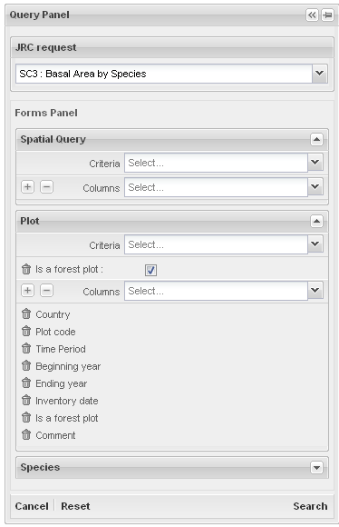
1
2
3
4

The query module is build completely dynamically with the content of the metadata.

It is composed of :
- A select box allowing the selection of the Dataset (1).
- Some Forms (Plot, Tree, Species, ….) (2)
- Inside each form we have a list of criteria and a list of result columns.
  - Criteria can be added using a select box called “select_criteria__FORMNAME” (3)
  - Result columns can be added using a select box called “select_column__FORMNAME” (4)
- Each criteria added is called “criteria__FORMNAME__FIELDNAME”.
- Each result column added is called “column__FORMNAME__FIELDNAME”.

When the form is submitted, a request is build using the list of criteria and result columns.

Field Type

The criteria and result fields that are defined in the metadata can be of different types :

Data Type

First, there is the type of the data (found in the unit metadata table). It is used in the result table component to know how to sort the data (dates are sorted chronologically and not alphabetically).

The allowed data types are :

- STRING
- INTEGER
- NUMERIC
- CODE
- DATE
- BOOLEAN
- GEOM (a geometric object)
- ARRAY (multiple choice of CODEs)

For some data type, we have defined some subtypes.

- NUMERIC
  - RANGE (a range of values with a min/max)
  - COORDINATE (a geographic coordinate)
- CODE or ARRAY
  - MODE (a code chosen in a list)
  - DYNAMIC (the authorised values are defined in the result of a SQL request)
  - TREE (a hierarchical tree of codes)
  - TAXREF (for taxonomic referentials)

Input Type

The input type is the type of HTML component that will be shown when the field is used as a criteria.

The allowed input types are :

- TEXT : a simple input type text (with autocompletion)
- DATE : a datepicker (special EXTJS component)
- NUMERIC : a numeric range picker (special EXT JS component)
- SELECT : a select box (linked to a list of codes)
- CHECKBOX : The corresponding data type should be ‘BOOLEAN’.
- GEOM : a geographic selection
- TREE : for hierarchical values
- TAXREF : for taxonomic referentials

Request generation

The request generation is done in the “_generateSQLRequest” method of the query controller.

The request is composed of 3 parts :
- The SELECT condition lists the list of selected columns
- The FROM condition lists the tables needed to execute the request
- The WHERE condition lists the criteria selected by the user.

Before to build the request, we look into the metadata database and get some information about the needed field and the tables they use.

For each table needed we get a list of its ancestors in the table tree hierarchy (the root of the tree is the table LOCATION whose ancestor is the special code *).

Using this hierarchy of tables we list the tables we will need to add to the join condition in the right order and with the good foreign keys.

We add to the WHERE condition, in addition to the user selected criteria, the conditions linked to the user role (we check the country codes).

For the complementary data, some extra work must be done because the data is stored in some column-oriented tables. This means that the condition on the JOIN must include the variable name in addition to the static foreign key and that the table can be joined more than one time (we need to manage correctly the tables alias names).

Map Panel

Map Toolbar
Layers and Legend Panel

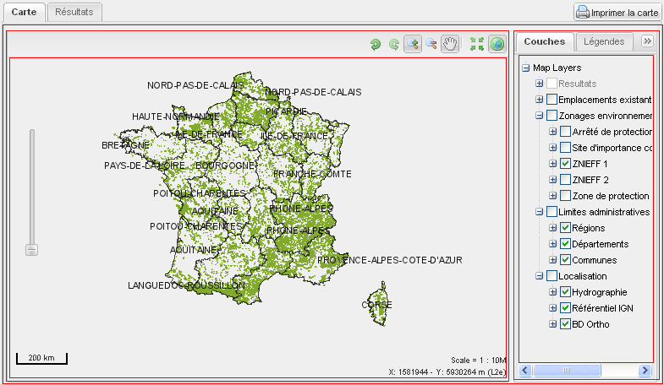

Geo Panel
Map Panel
Layer Panel

Result Panel

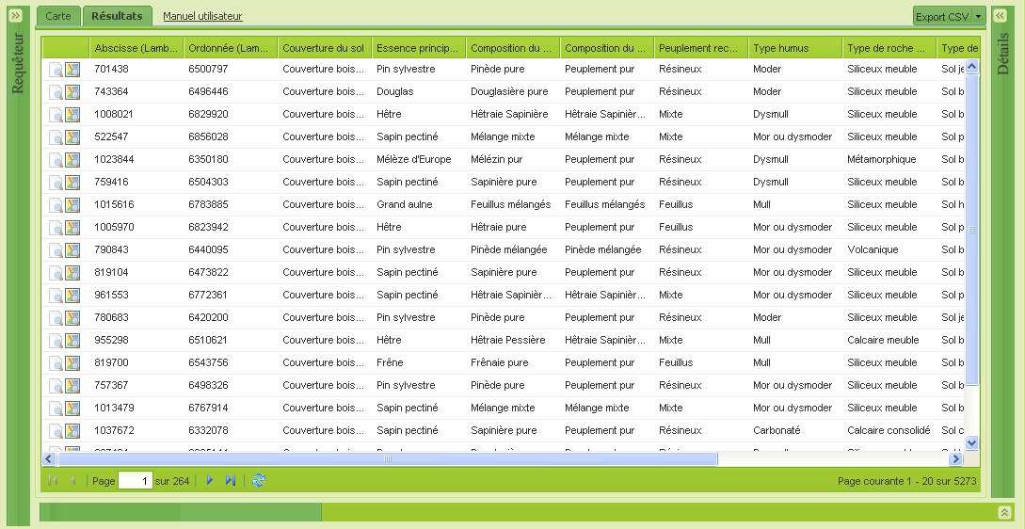

Detail view

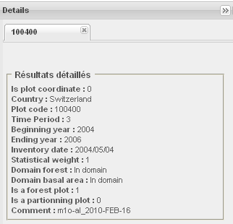

The detail view is using the “_generateSQLDetailRequest” method of the query controller to request from the database all the data available for one table.

An unique ID is generated when a request is first executed by the user. This ID is composed of the concatenation of all the primary keys of the tables used in the query.

Then, when a user click on the detail button of the result panel, we rebuild the hierarchy of tables (using the leaf table that is stored in session)) and we create a new request which will give us all information for this unique ID.

When a used click on the “information” button on a plot on the map, we manually generate the unique ID corresponding to the “PLOT_DATA” level and we launch the previous procedure.

For example:
If a user has done a request using plot data and species data. Each line of the result will have a unique ID that will correspond to the “SPECIES_DATA” level of information. We store “SPECIES_DATA” as the leaf table and we send to the client (the javascript part) the unique ID for each line.

The user click on a line to have the corresponding detailed information, it will generate a request “getMapDetail()” with an ID like “34_1_01575-14060-4-0T_5”.

We then generate a new SQL request that will have the same unique ID construction.

Predefined Requests

A simplified interface have been designed in order to help the user.

Instead of composing a query thru the query module, this interface propose a list of predefined requests.
These requests have a definition, a list of predefined parameters and can also have some undefined parameters that are selected by the user.

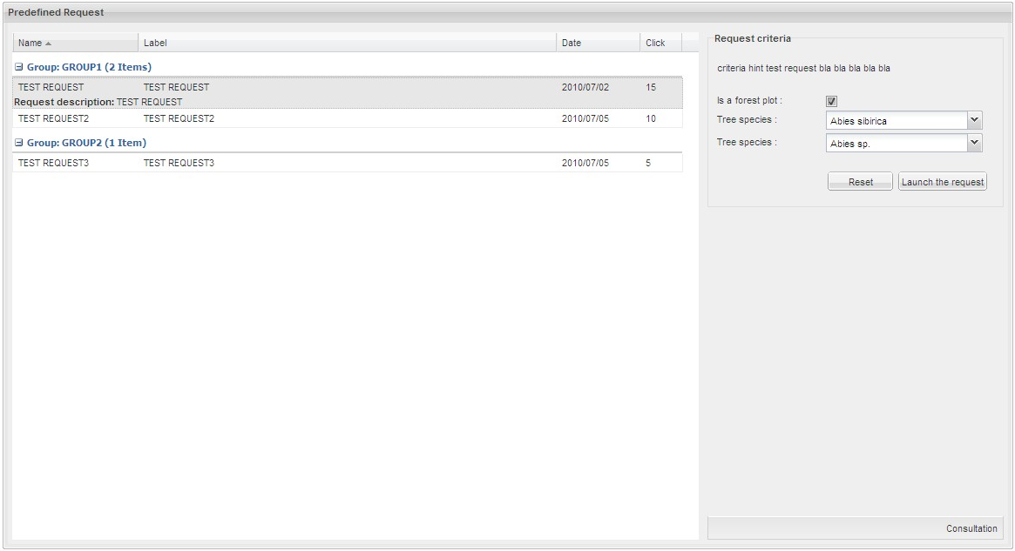

The tables were are defined these predefined requests are stored in the “website” schema.

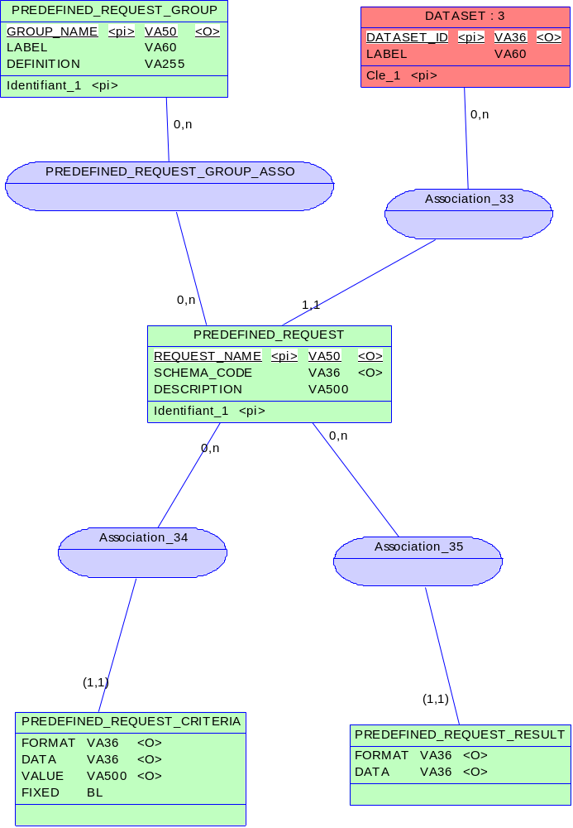

The “PREDEFINED_REQUEST” table contains the definition of the predefined request. The CRITERIA and RESULT tables contains the list of parameters of the request and their values (it’s the same system as for the default values).

The “PREDEFINED_REQUEST_GROUP” table allow us to regroup the request by logical categories.

When the user select a predefined request, the query module is initialised with the saved request parameters, the query panel is hidden and the request is launched directly.

Layer Management
The list of available layers is build dynamically for a user by using some information stored in database.

The “layer_definition” table store the list of available layers and their properties (label, scale of apparition, …).

Layer_definition
Field | Description
layer_name | Logical name of the layer
layer_label | Label of the layer
mapserv_layers | Name of the corresponding layer(s)
isTransparent | Indicate if the layer is transparent
isBaseLayer | Indicate if the layer is a base layer (or an overlay)
isUntiled | Force OpenLayer to request one image each time
isCached | Use Tilecache
maxscale | Max scale of apparation
minscale | Min scale of apparition
has_legend | If value = 1 is the layer has a legend that should be displayed
transitionEffect | Transition effect (resize or null)
imageFormat | Image format (PNG or JPEG)
opacity | Opacity (between 0 and 100), null if no transparency

The “legend” table store the information used to build the TreeView displaying the list of layers to the user. It can link each layer to a parent layer or category.

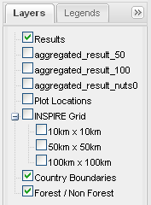

Legend
Field | Description
item_id | identify the item
parent_id | identify the parent of the item (-1 = root)
is_layer | if value = 1 then this is a layer, else it is only a node
is_checked | if value = 1 then the item is checked by default
is_expended | if value = 1 then the node is expended by default
name | logical name of the layer or label of the node
position | position of the layer in its group

Layer restrictions

To know if a user can see a given layer or not, we have implemented 3 mechanisms of restriction.

Restriction by country

By default a layer can be seen by any country.
We add a “country_code” column in the layer definition table to allow us to limit some layers to certain countries.

This is used by the 1km x 1km grid for example.

Restriction by profile

By default a layer can be seen by anybody. We create a new table “Layer_Profile_Restriction” where we can forbid the access of a given layer to a given profile of user.

This can be used for example to forbid the JRC from accessing data with exact plot location.

Restriction by activation

By default a layer can defined in the “layer_definition” table is visible at any moment. Some layers have some pre-requisites, for example the aggregation results layers require that the aggregation computation has been done.

We add a “needActivation” flag in the “layer_definition” table. When a layer is activated, we store its logical name in the user session, which make it appear on the available layer list.

Layer styling

We want to be able to let user personalize the rendering of some layers (for example, the result of an aggregation).

In order to do this, Mapserver allow us to use a user-defined configuration instead of the default configuration of the layer. This user-defined configuration is an XML document called SLD (Styled Layer Description).

Architecture 1

Our first approach was to add to the URL of the request the link to a SLD document that would be generated dynamically.

Browser
Web Site
PHP

Mapserver
getMap
Proxy
Map
getMap
getSLD

The problem with this technique is that during the “getSLD” request, it’s mapserver that originates the request and not the user. We cannot know if this request is valid (if the user is loggued) and we lose the context of the user (the user session contains some information like the current dataset, …).

Architecture 2

In order to solve this problem, we must make sure that the request is coming from the user.

Mapserver allow us to directly send the SLD with the getMap request instead of giving a link to an URL (use of the “SLD_BODY” parameter).

Proxy
Map

Browser
Web Site
PHP

Mapserver
getMap
getMap + SLD
getSLD

We are only using the SLD on some layers, we use the “HAS_SLD” parameter to detected layers that have some prerequisites before to be used.

If this parameter is detected in the URL by the proxy, the request is intercepted, the name of the layer is extracted and a SLD is generated dynamically.

Annexes

Deployment

Javascript build

The ‘build.xml’ script is located in the ‘website’ directory. This script allow us to prepare the website for the deployment in the production environment.

The following targets are available:
- jsdoc : Generate the javascript documentation into the ‘hudson/docs/genapp/jsdoc’ directory.
- phpdoc : Generate the php documentation into the ‘hudson/docs/genapp/phpdoc’ directory.
- compressCssThemes : Compress the css themes.
- compressJavascript : Compress the javascript.
- compressOl : Compress the openLayers library.
- phpcheckstyle : Launch PHP CheckStyle (static analysis of the source code).
- deployWebSite : Build the web site (copy all the needed directories in one place).

User extension for extjs

The user extensions are into the ‘extjsux‘ directory.
For the checkbox criteria, a extjs user extension named ‘basiccheckbox’ has been added. This give the possibility to have into the post a parameter with the value 0 or 1 when the checkbox is unchecked or checked. Not like the default html checkbox comportment.

Patch and locale

The patch are into the ‘genapp/source’ directory and named ‘patch-eforest.js’
This file give the possibility to change the default settings for the consultation page.
For all the parameters available see the genapp api.

‘patch-eforest.js’ file:
// Default parameters
if(Genapp.ConsultationPanel){
Ext.apply(Genapp.ConsultationPanel.prototype, {
hideDetails : false, // Display the link result to details
hideMapDetails : false, // Display the link map to details
hideCsvExportButton : Genapp.grid.hideExportCSV // Set the property to the value of Genapp.grid.hideExportCSV
});
}

// Reduction of the application size in function of the web site margins
if(Genapp.ConsultationPanel){
Ext.apply(Genapp.ConsultationPanel.prototype, {
widthToSubstract:120,
heightToSubstract:210
});
}

The locale files contains the translations for the genapp application. (The consultation page)
There are into the ‘genapp/source/locale’ directory.
For all the translation available, see the genapp-lang-fr.js file and the genapp api.

Part of the ‘genapp-lang-fr.js’ file:
if(Genapp.form.DateRangeField){
Ext.apply(Genapp.form.DateRangeField.prototype, {
minText : "Les dates contenues dans ce champ doivent être égales ou postérieures au {0}",
maxText : "Les dates contenues dans ce champ doivent être égales ou antérieures au {0}",
reverseText : "La date de fin doit être postérieure à la date de début",
notEqualText : "Les dates de début et de fin ne peuvent être égales"
});
}
if(Genapp.form.GeometryField){
Ext.apply(Genapp.form.GeometryField.prototype, {
fieldLabel: "Localisation",
mapWindowTitle: "Dessinez la zone recherchée sur la carte :",
mapWindowValidateButtonText: "Valider",
mapWindowCancelButtonText: "Annuler"
});
}
…

Openlayer extensions

We have customized a new control for OpenLayers that allow us to generate a WFS request to mapserver when a user click on the map. The ‘FeatureInfoControl.js’ file have been added into the ‘genapp/source/openlayers’ directory. This control gives up the possibility to get some information about a plot and to open the details panel when the user click on a feature on the map.

